**February Fitness Fun**

**Get up off the couch, away from the T.V., and join us for a jog around the District. You don’t have to jog but you do have to move. For every mile, or 10 to 15 minutes of moving, you color in a block on the map. If you move ½ a mile, you color in half of a block. Feel free to use the chart below for some ideas, but know that you are not limited to these activities. Start at Bradford Woods and see how quickly you can “jog” around the District. When you complete the map, return it to Mrs. Frisco for extra credit and your completed map will be displayed for all to see.**

|  |  |
| --- | --- |
| **Activity** | **Minutes that equal a mile** |
| **Basketball** | **12 minutes** |
| **Soccer** | **12 minutes** |
| **Swimming** | **16 minutes** |
| **Dancing** | **15 minutes** |
| **Jump Rope** | **10 minutes** |
| **Jogging** | **10 minutes** |

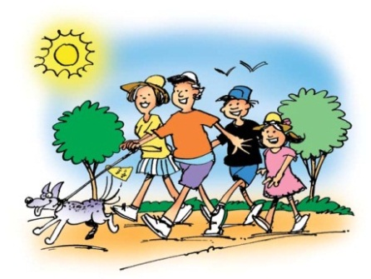[](http://images.google.com/imgres?q=clipart+kids+dancing&hl=en&gbv=2&biw=1440&bih=754&tbm=isch&tbnid=PjFN4vX7vBM7OM:&imgrefurl=http://www.clipartof.com/portfolio/prawny/illustration/childs-sketch-of-kids-dancing-under-a-disco-ball-214287.html&docid=NdaRs6KR9bfyQM&imgurl=http://images.clipartof.com/small/214287-Royalty-Free-RF-Clipart-Illustration-Of-A-Childs-Sketch-Of-Kids-Dancing-Under-A-Disco-Ball.jpg&w=418&h=450&ei=qUAgT4ekPOjZ0QHLlukH&zoom=1) [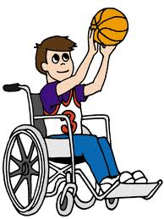](http://images.google.com/imgres?q=clipart+kids+basketball&hl=en&gbv=2&biw=1440&bih=754&tbm=isch&tbnid=teb_nvGhbBfWzM:&imgrefurl=http://haventeam.com/betsie/parser.cgi/0005/abcteach.com/directory/basics/sports_physical_education/basketball/&docid=4ZAqlBoYjmBefM&imgurl=http://haventeam.com/betsie/parser.cgi/0005/www.abcteach.com/free/d/disabledbasketballplayerrgb.jpg&w=900&h=1200&ei=VkEgT6f7JoH50gGBspAI&zoom=1)

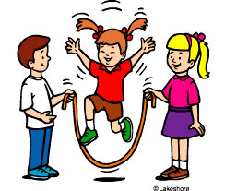 [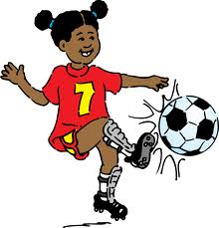](http://images.google.com/imgres?q=clipart+kids+playing+soccer&hl=en&gbv=2&biw=1440&bih=754&tbm=isch&tbnid=fN_V1b643QvLuM:&imgrefurl=http://www.clker.com/clipart-9458.html&docid=H0YsoyEvRcFWCM&imgurl=http://www.clker.com/cliparts/5/7/d/c/11954223871731788173johnny_automatic_girl_playing_soccer.svg.hi.png&w=570&h=595&ei=2UAgT_eCL9GG0QGDl4AI&zoom=1) [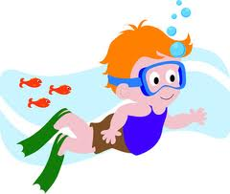](http://images.google.com/imgres?q=clipart+kids+swimming&hl=en&gbv=2&biw=1440&bih=754&tbm=isch&tbnid=GZk-SmFeNHlz9M:&imgrefurl=http://www.kidclipart.net/free_kid_clip_art_pictures/child_swimming_with_fish_0515-1102-2022-0353.html&docid=sd3LZuYh_X9g5M&imgurl=http://www.kidclipart.net/free_kid_clip_art_pictures/child_swimming_with_fish_0515-1102-2022-0353_SMU.jpg&w=300&h=254&ei=E0EgT9PIBMrv0gHG0anOAg&zoom=1)